DIGITAL STROBOSCOPE
Model : DS-3200 (60.0 to 30,000 RPM/FPM)
Model : DS-2200 (60.0 to 18,000 RPM/FPM)
Model : DS-1000 (60 to 10,000 RPM/FPM)
(Without Display, Rotary adjustment)
(AC100V, AC110V, AC220V, AC240V)
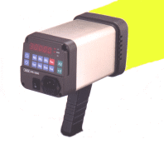 | Keyboard Operating, Wide Range, High Accuracy.  A complete digital design for speed measuring,  general industrial maintenance, quality control,  production, laboratories and for schools and  colleges for demonstrating strobe action.  Three complete setup memory.  Special function "×2" and "÷2"  for check the stop motion is actual speed.

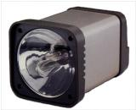
  Actual Speed RPM | Stroboscope RPM/FPM | Multiple | Stop Motion Images
  3,000 | 12,000 | 4 | 4
  3,000 | 9,000 | 3 | 3
  3,000 | 6,000 | 2 | 2
  3,000 | 3,000 | 1 | 1
  3,000 | 1,500 | 1/2 | 1
  3,000 | 1,000 | 1/3 | 1

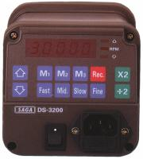  DS-3200 | 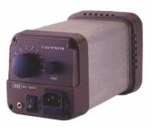  DS-1000 | Rotary RPM/FPM adjustment.  Fine adjustment.  External trigger.
SPECIFICATION
Model | DS-3200 | DS-2200 | DS-1000
Setup Range | 60.0 - 30,000 rpm | 60.0 - 18,000 rpm | 60.0 - 10,000 rpm
Resolution | 0.1 rpm/fpm below 2,000 rpm  1 rpm/fpm above 2,000 rpm
Display | 5 digits LED, 10mm High
Setup Accuracy | ±0.01%
Temp. Drift | ±0.01%
Lamp | Xenon flash lamp
Special Function | Multiplier (×2) flashes, Divider (÷2) flashes  Three complete setup memory (M1, M2, M3)  Four speeds (Fast, Middle, Slow, Fine) adjustment for quick setting stability. |  | Rotary RPM adjustment.  Fine adjustment.  External trigger.
Power Supply | AC 110V or 220V±10%, 50/60 Hz (Please specify voltage when placing orders.)
Power Consumption | Approximately 25 watts. (Full range)
Operating Temp./Humidity | 0℃ to 50℃ (32℉ to 122℉), Below 85% RH.
Dimension | 115 x 115 x 200 mm. without handle (removable)
Weight | Approximately 1.5Kgs
Standard Accessories | AC power cord, Xenon Lamp, Operation Manual
Optional Accessories | Carrying case (DS-CASE)  Xenon Lamp DS-FT-01 (DS-FT-03 for DS-1000)
* Appearance and specifications listed in this brochure are subject to change without notice.

